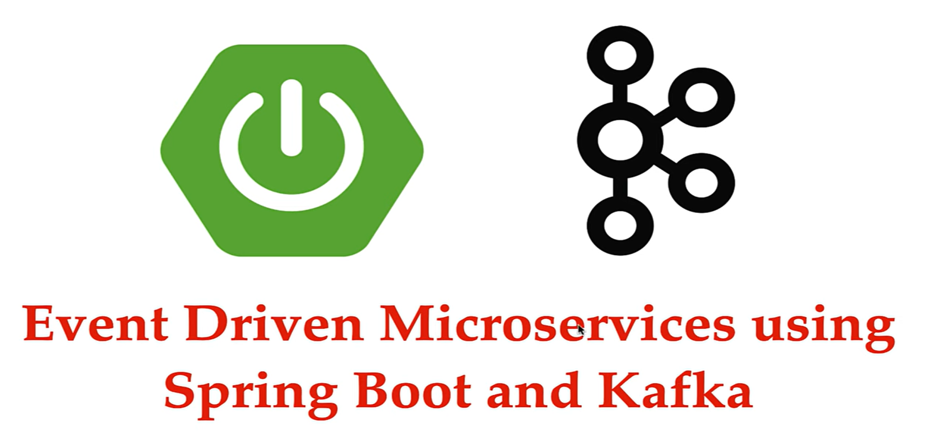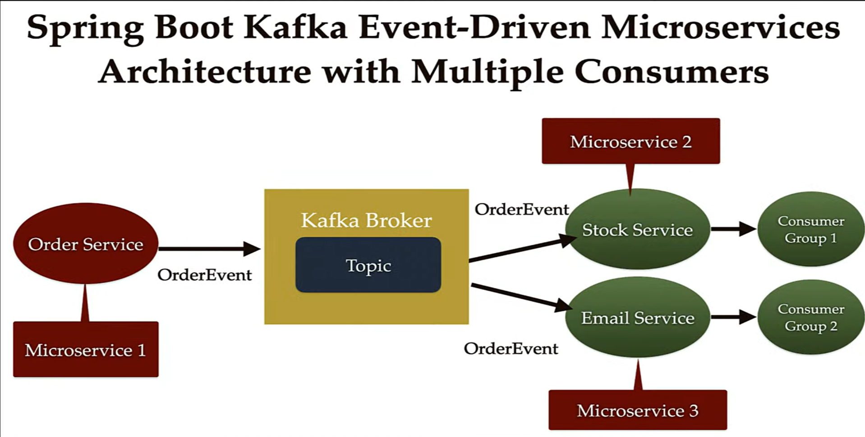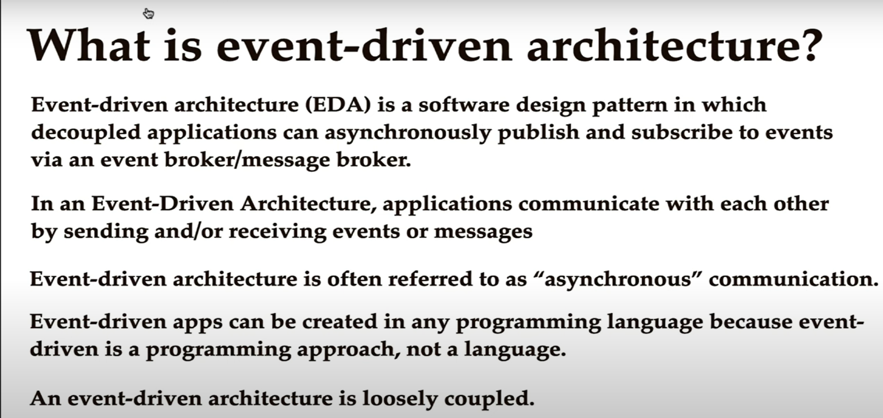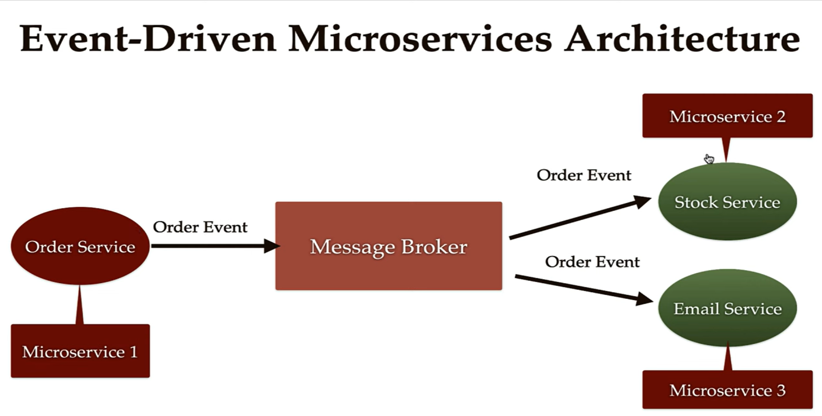

If we want to create other more services like packagingService, PaymentService, SMSServices.

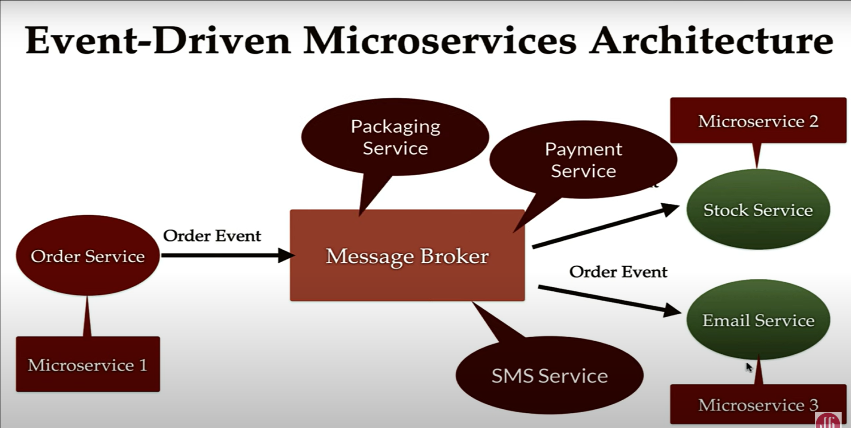

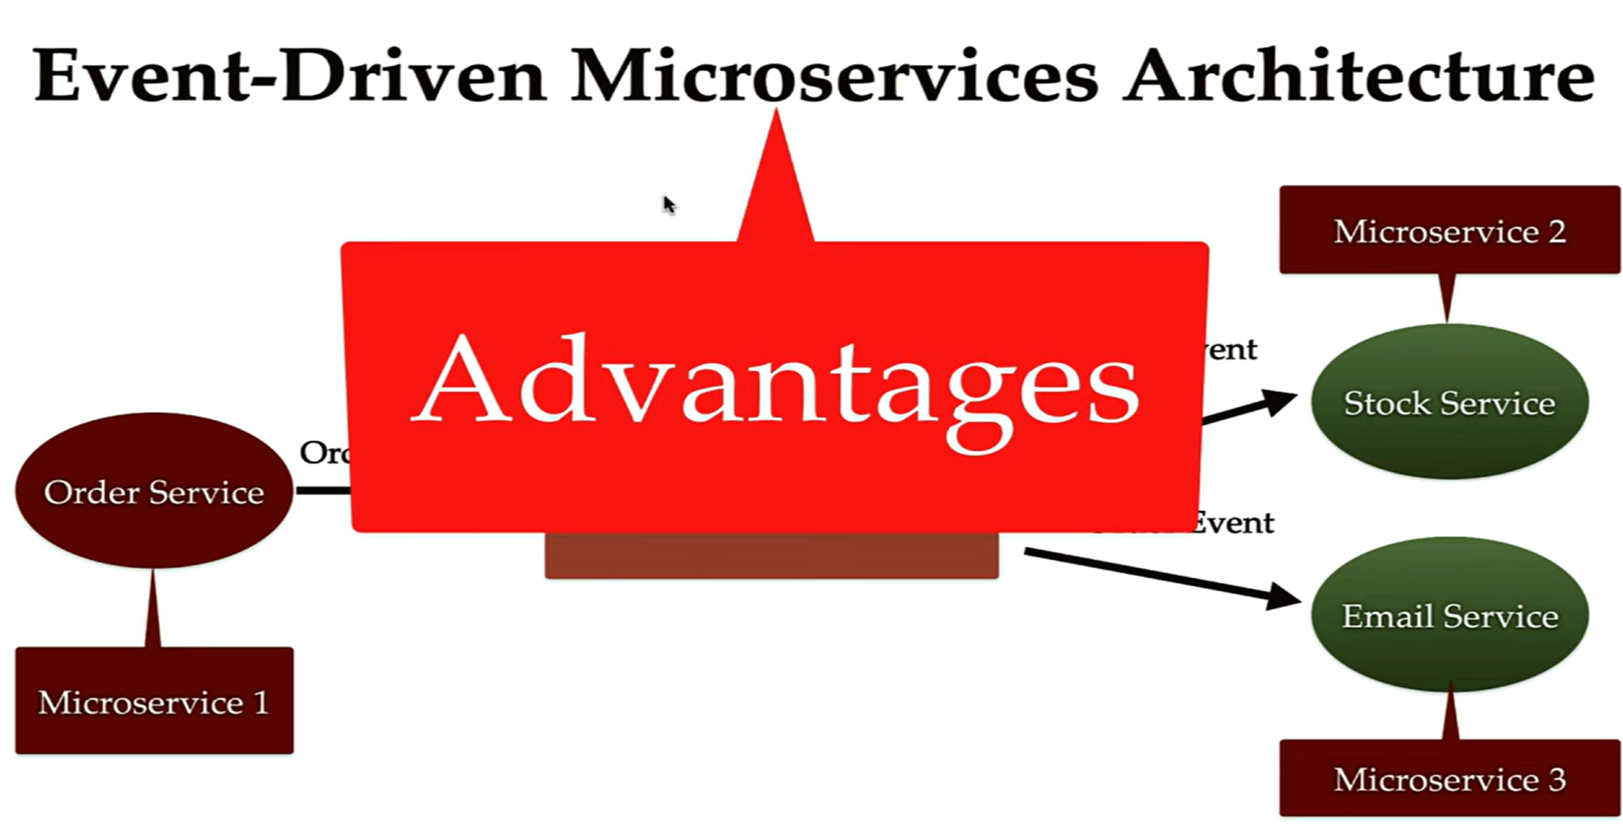

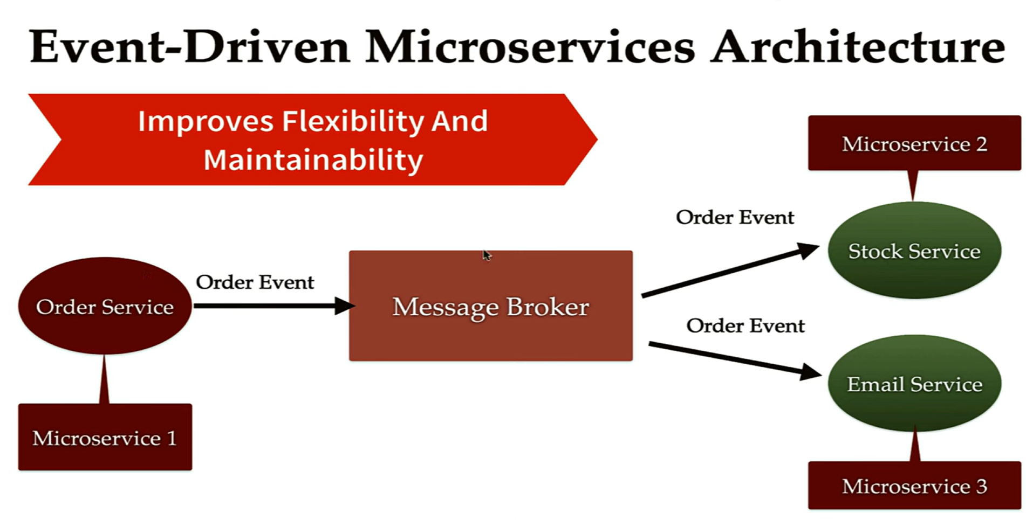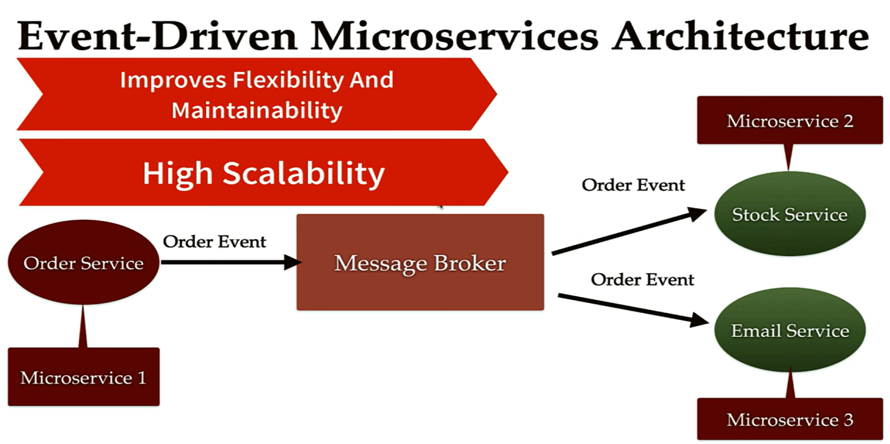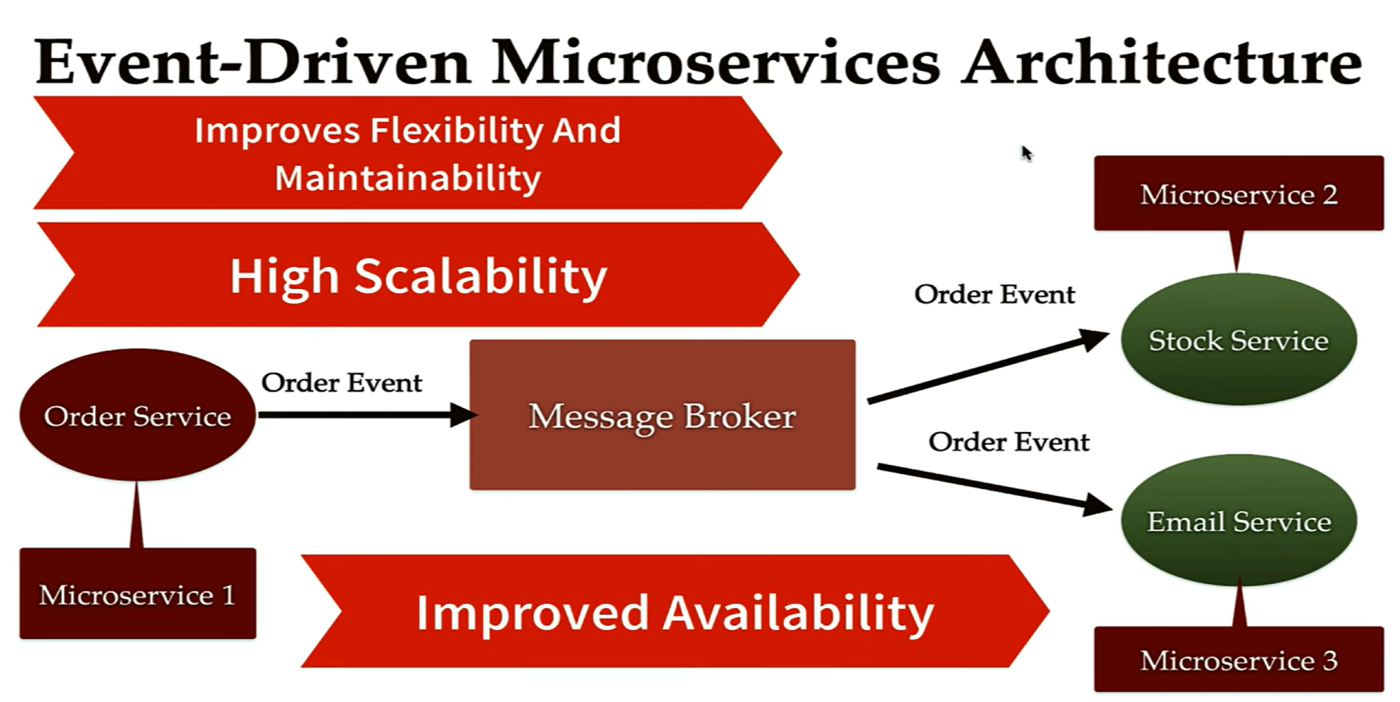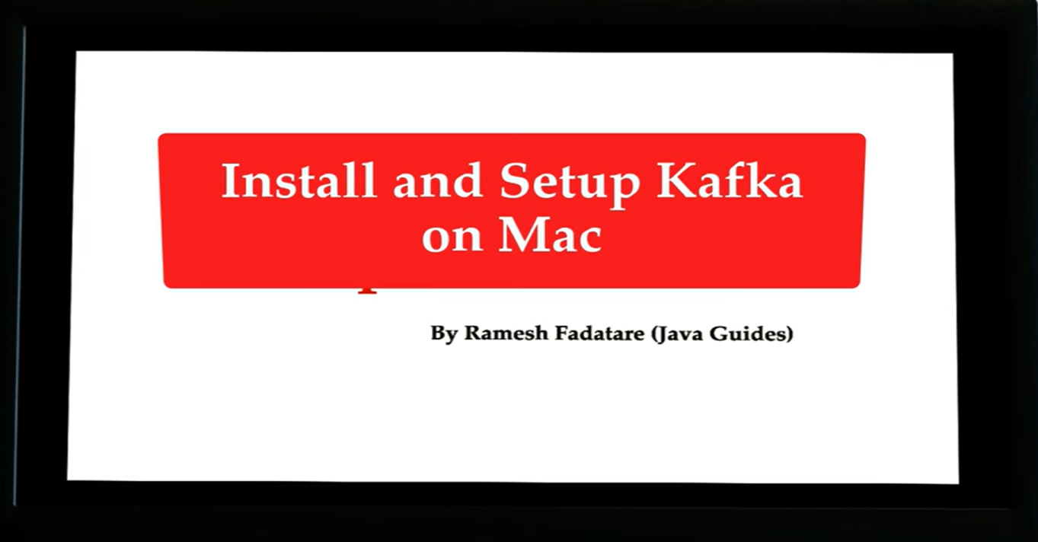

<https://kafka.apache.org/quickstart>

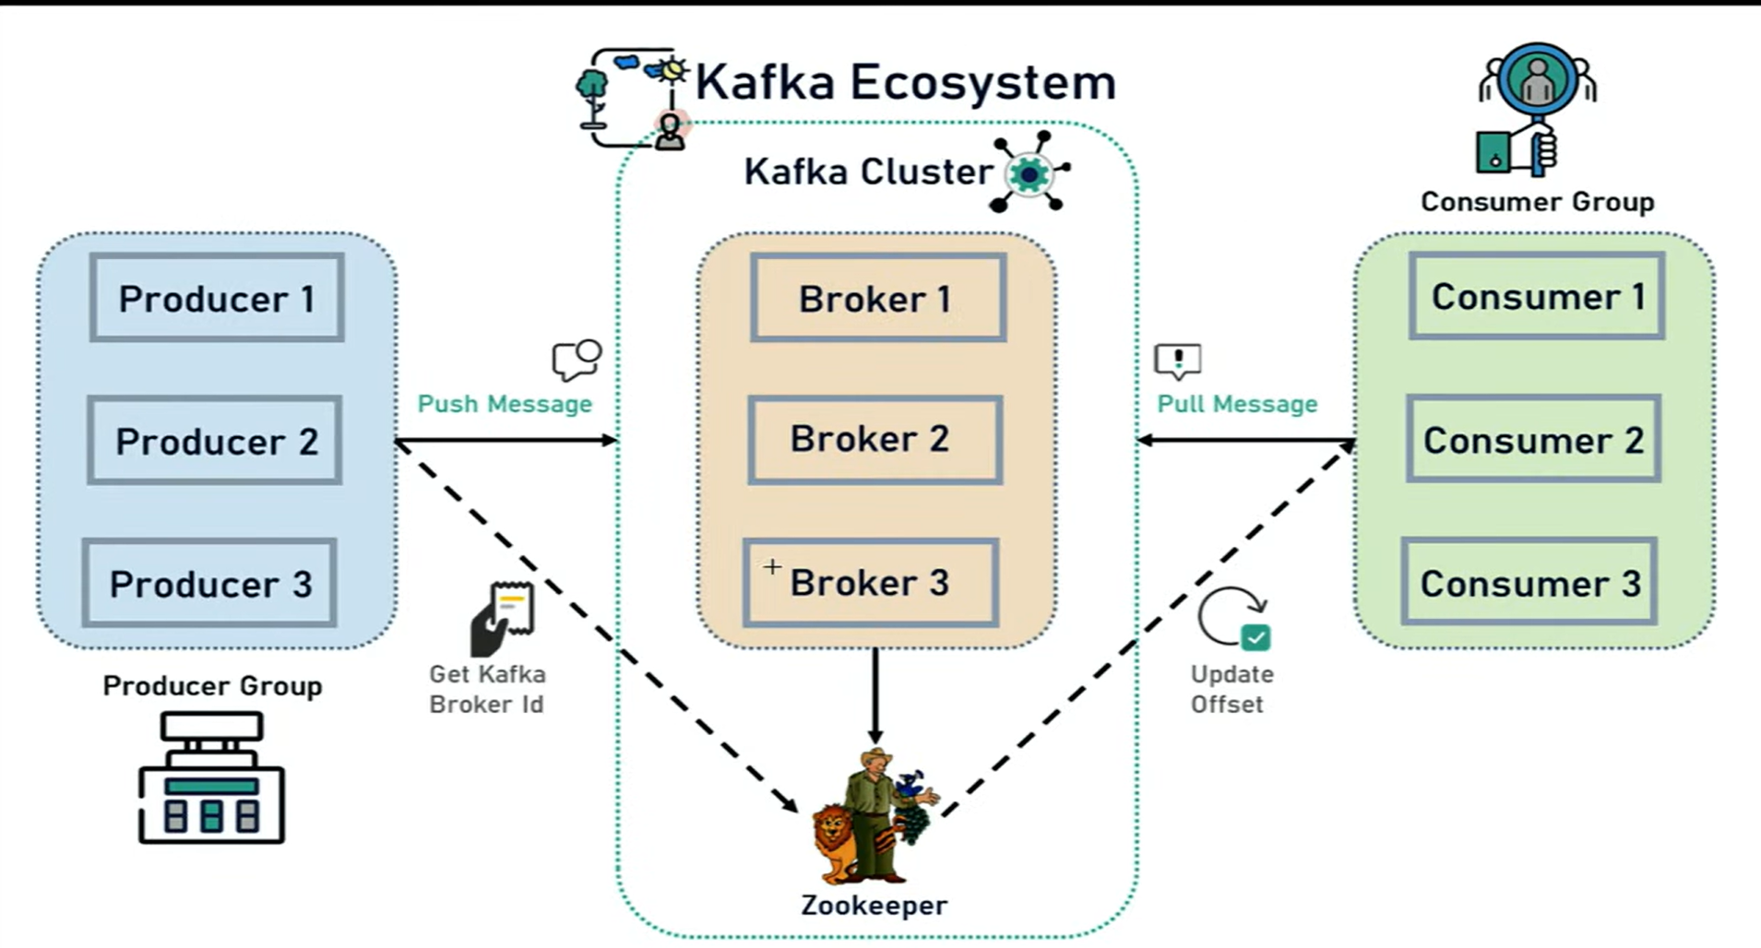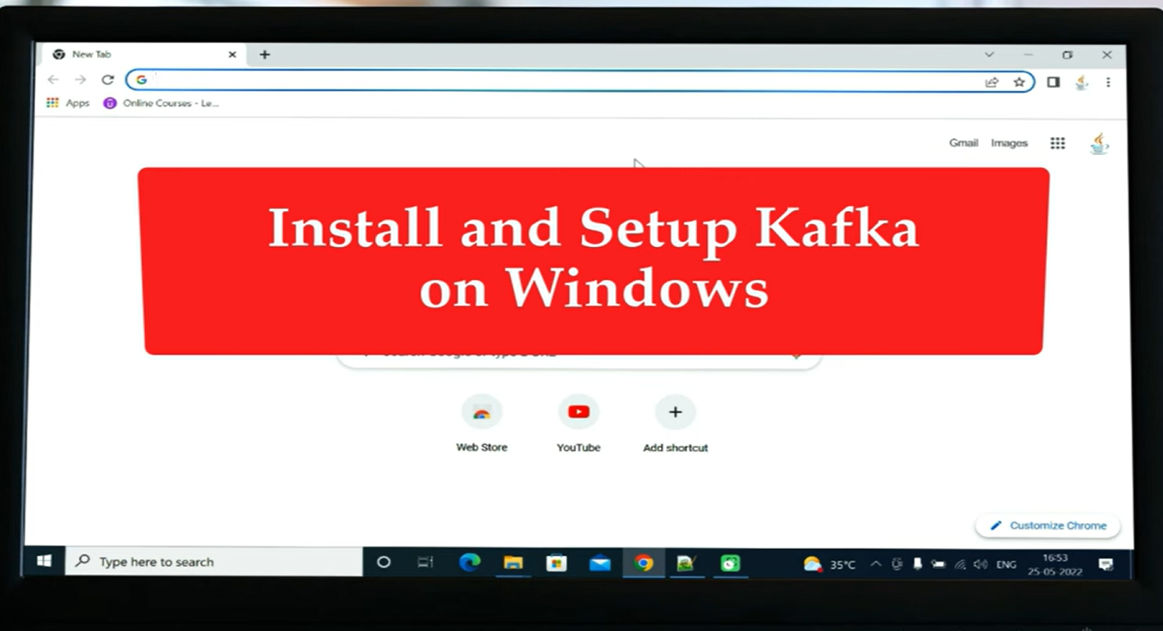

**Start Zookeeper**

D:\kafka>.\bin\windows\zookeeper-server-start.bat .\config\zookeeper.properties

**Start Broker server**

D:\kafka >.\bin\windows\kafka-server-start.bat config\server.properties

**Create Topic**

D:\kafka >.\bin\windows\kafka-topics.bat --create --topic topic-example --bootstrap-server localhost:9092

**Open console to send message to broker**

D:\kafka >.\bin\windows\kafka-console-producer.bat --topic topic-example --bootstrap-server localhost:9092

**Consume the message**

D:\kafka >.\bin\windows\kafka-console-consumer.bat --topic topic-example --from-beginning --bootstrap-server localhost:9092

Create microservice

